Exam 1
CHM 221-Organic I
Instructor: Desmond Kwan

Please print your name:________________________________

I. M.C. Circle the appropriate answer. (60 pts)
Write your answers in the appropriate boxes shown on page 3.

1.Provide the IUPAC name for the molecule shown below:
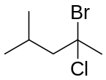

(a) 4-ethyl-3,5-dimethyloctane (b) 4-bromo-4-chloro-2-methylpentane (c) 2-methyl-4-bromo-4-chlorohexane (d) 2-bromo-2-chloro-4-methylpentane (e) 2-chloro-2-bromo-4-methylpentane
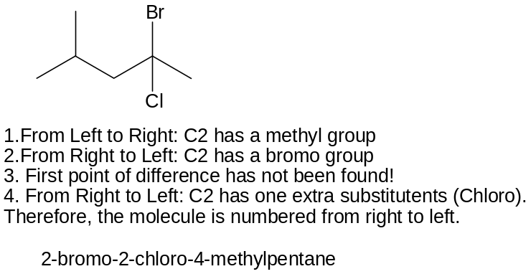

2. Choose the correct hybridization for the atom indicated in the molecule below.
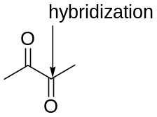
(a) sp³ (b) sp² (c) sp (d) sp³d² (e) none of the above

3. The conjugate base of 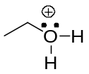 is:

Answer: C

4. Provide the IUPAC name for the molecule shown below:

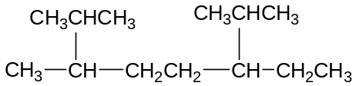

a) 3-ethyl-2,6,7-trimethyloctane b) 1,3,5-trimethylcyclopentane c) 2,5-diisopropylheptane d) 1,1,4-cyclopentane e) none of these answers

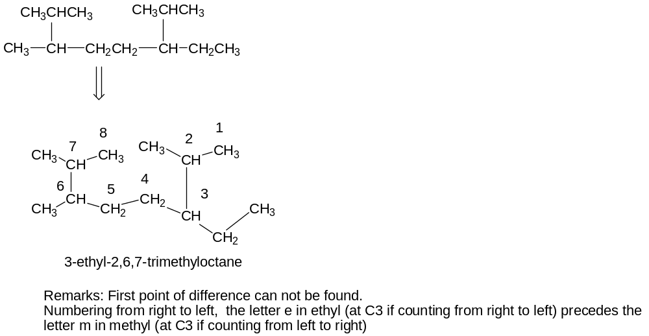
5. Choose the identical molecule for the structure shown below:
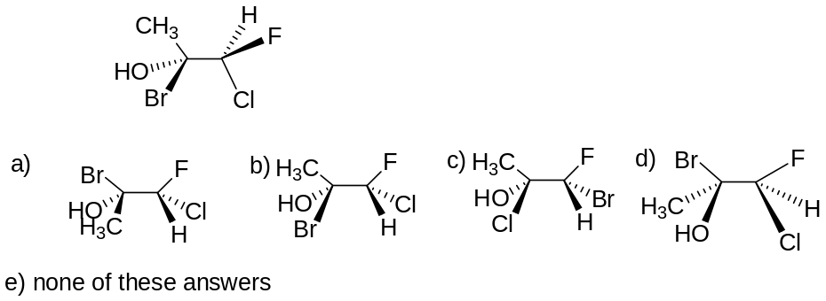

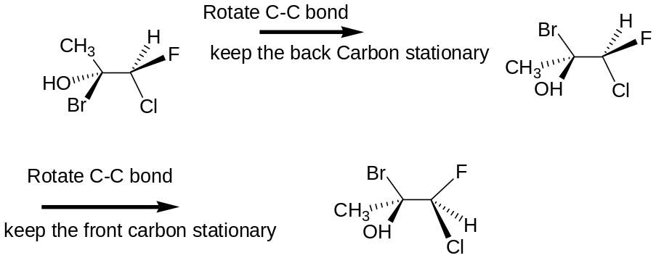
Answer: D
6. Choose the identical molecule for the structure shown below
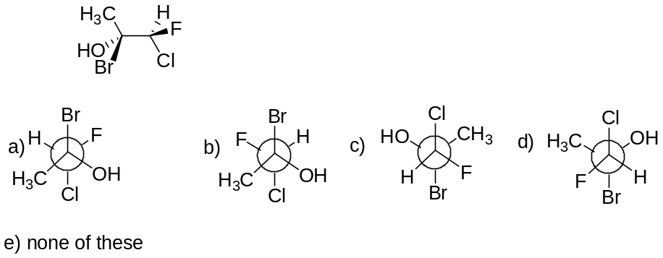

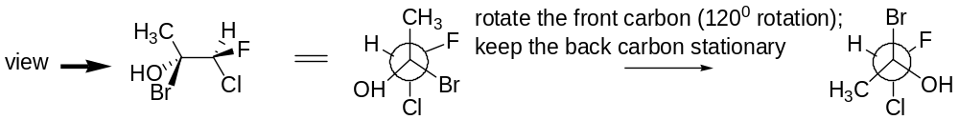
Answer: A

7. Choose the identical molecule for the structure shown below:
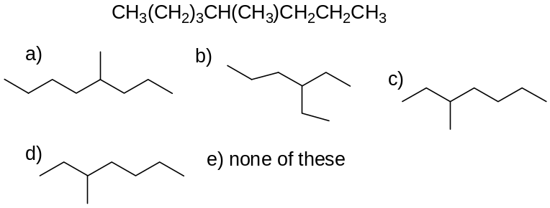

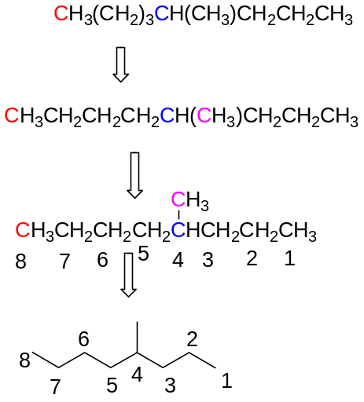
Answer : A

8. Predict the reasonable resonance structure for the structure shown below:
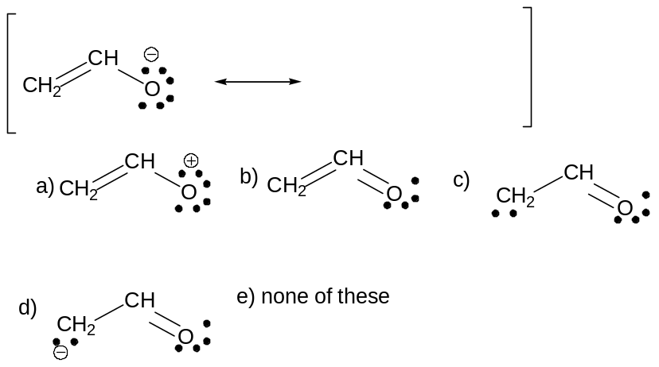
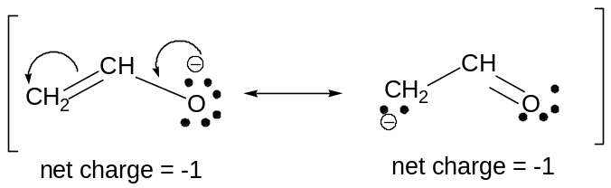
Answer: d

9. Choose the most stable conformation for butane:
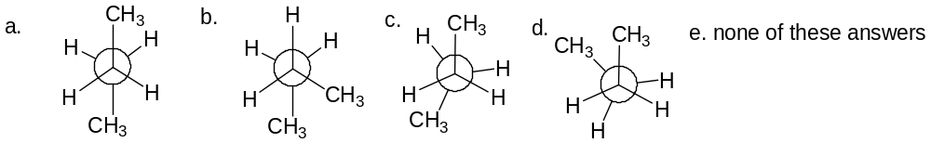

Answer: a. (Two methyl groups are anti to each other)
12. Predict the alternate chair conformation.
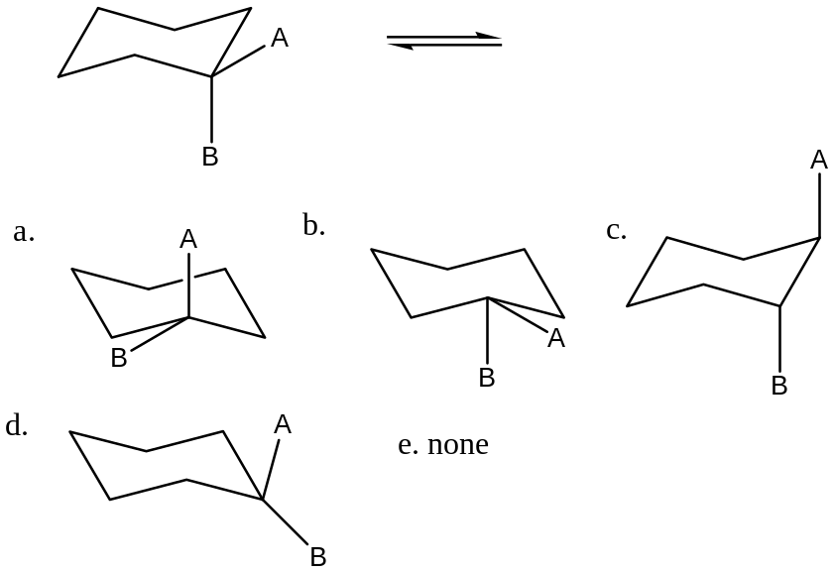
Answer: a (see supplementary material)
13. Which of the following is a primary alkyl halide?
a) Methyl bromide b) 1-propyl fluoride c) t-butyl iodide d) isopropyl bromide e) none of these answers
answer: b
14. Name the following alkyl group (substituent)
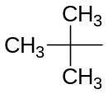
a. methyl b. ethyl c. isopropyl d. tert-butyl e. none of these answers
15. Name the following alkyl group (substituent)
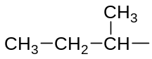
a. sec-butyl b. propyl c. isobutyl d. butyl e. none of these answers.

16. For each pair of ions, determine (circle) which ion is more stable. Use resonance to explain your answers (10 pt)
a.
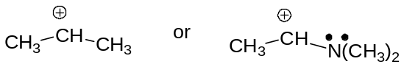

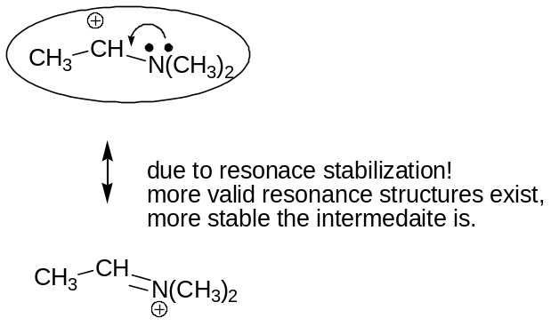
b.

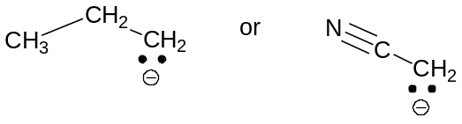
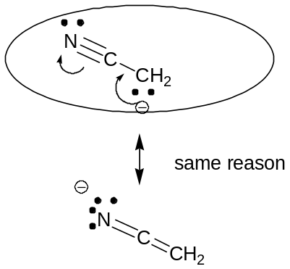
17. How many (max. no.) of possible stereoisomers (enantiomers + diasteromers) are there of the molecule shown below (hint: determine the no. of chiral carbons and use a formula discussed in class)?
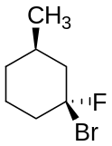 a) 1 b) 2 c) 8 d) 5 e) 4

Answer: e, 2 chiral carbons
18. What is the correct stereochemical description of the relationship between this pair of molecules?
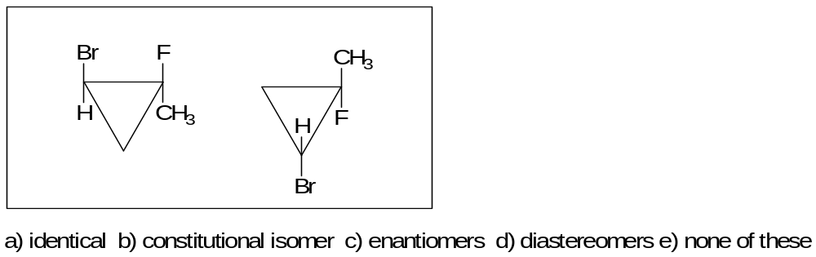
Answer: a
19. Which is the enantiomer of this compound?
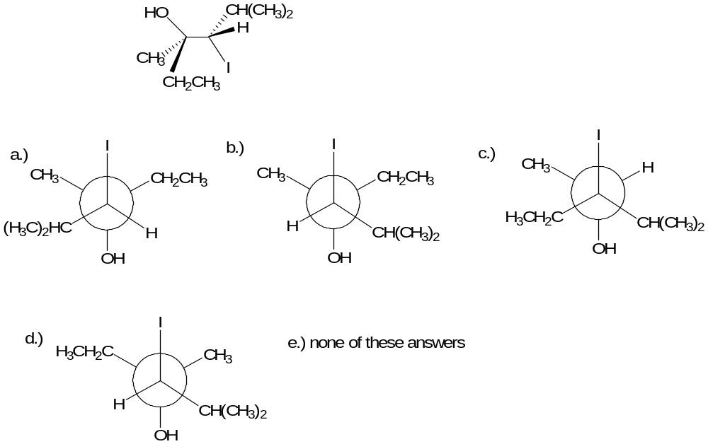
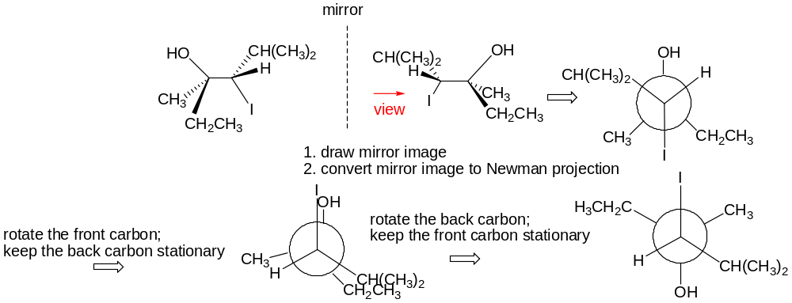
Answer : d
20. Which is the identical molecule of the compound shown in question 19?
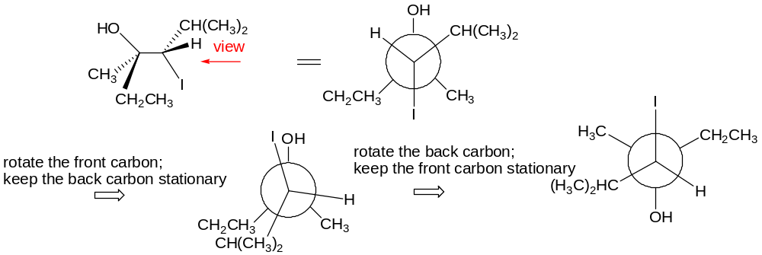
Answer: A
21. Which is the diastereomer of the compound shown in question 19?
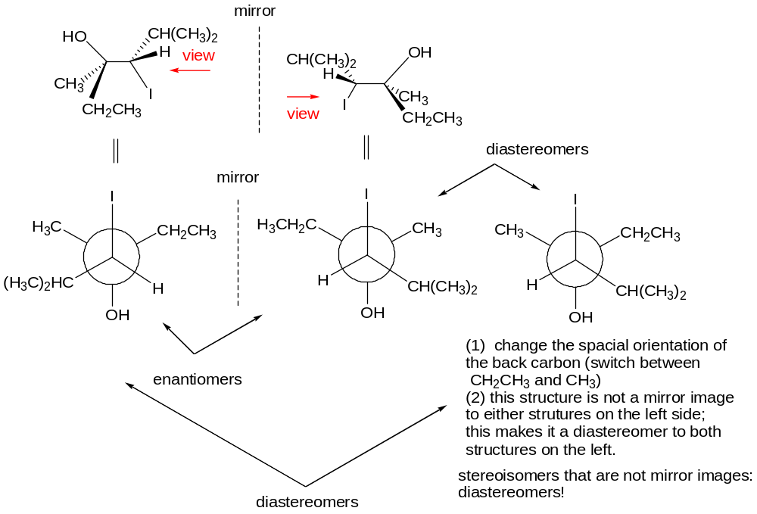
Answer: B
22. Which is the constitutional isomer of the compound shown in question 19?

Answer: C (different bond orders: CH₃CH₂ and H are on two different chiral carbons (switched))

23. Predict the alternate chair conformers for the following structures: (5 pts)

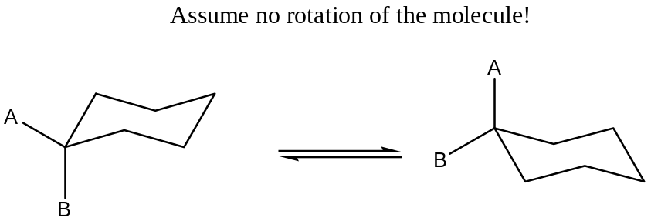

24.
Find the asymmetric carbon atom(s) of the molecule shown below, and determine the (R) or the (S) configuration of each asymmetric carbon atom(s) (pts).
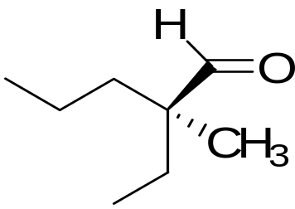

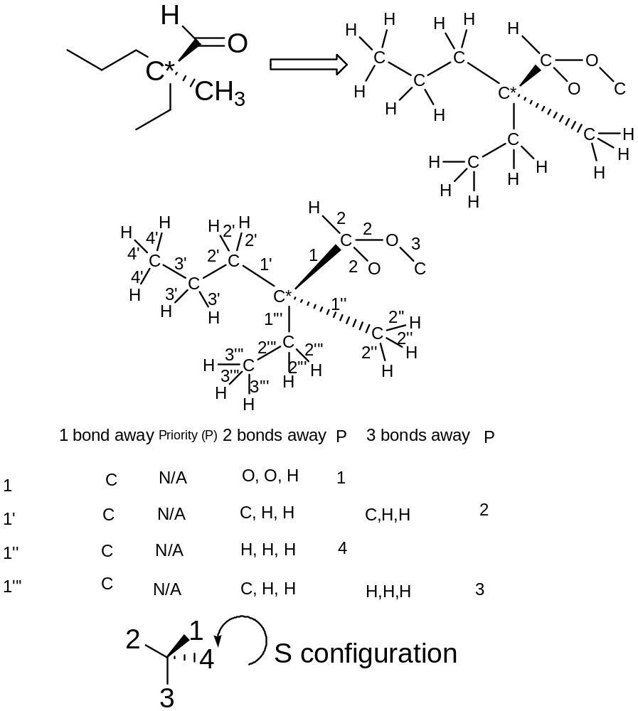

25. ( pts) (a)Draw both chair conformations of cis-1,3-diethylcyclohexane, and determine which conformer is more stable.
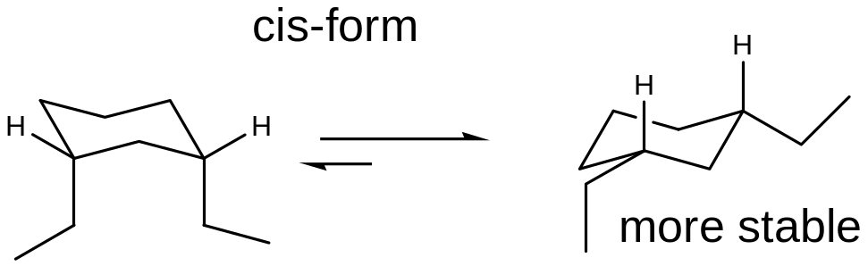

(b) Repeat for the trans isomer.
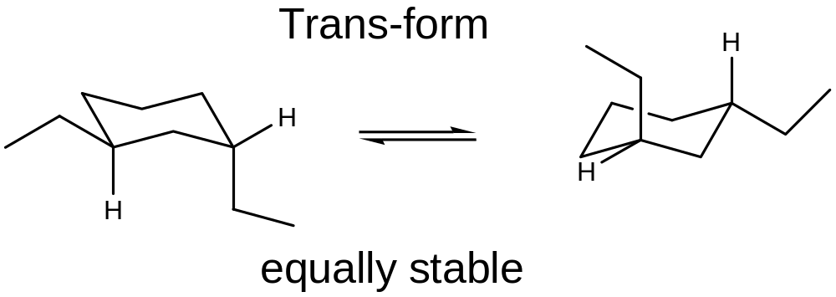
(c) Predict which isomer (cis or trans) is more stable.
Compare the stable one from each isomers.
Cis-form is more stable in this case (this may not apply to other disubstituted cyclohexane molecules)!

